New Image o UOW

**Informatics Institute of Technology**

**Department of Computing**

**BSc Business Information System**

**Module: 4COSC0011C Web Design & Development**

**Module Leader: Ms.Aloka Fernando**

**Individual Coursework Report**

Tutorial Group : BIS

Coursework Group No : Group 03

Student IIT ID : 2018458

Student UoW ID : w1742062

Student First Name : Sajani Lavanya

Student Surname : Ratnayake

© University of Westminster 2019

Contents

Introduction 3

Technical Discussion 5

2.1 About Us 6

6

2.2 Quiz 7

2.3 CV 9

2.4 Part 2 10

# Introduction

This coursework is based on creating a website using HTML, CSS and JavaScript. This website is about MARVEL Studios. To do this coursework we divides into group of 4 members. To make this website more attractive and effective we used various new technologies. As I’m student number 3 my tasks were to create the “Quiz” and the “About Us” page. In our website there is a home page, Quiz, Gallery, Store, Feedback form, Site map and About Us page. According to the given guidelines in the coursework specification I have completes this coursework successfully with highly valuable experiences.

|  |  |  |  |  |
| --- | --- | --- | --- | --- |
| **Task** | **Student 1**  **Harithroo** | **Student 2**  **Thinura** | **Student 3**  **Sajani** | **Student 4**  **Nadeera** |
| Presentation Page |  |  |  |  |
| Main page |  |  |  |  |
| Font size change |  |  |  |  |
| Comments form |  |  |  |  |
| Store |  |  |  |  |
| Quiz |  |  |  |  |
| Gallery |  |  |  |  |
| About us |  |  |  |  |
| External CSS |  |  |  |  |
| CV |  |  |  |  |
| Logo/Page editors |  |  |  |  |
| Coursework Part B |  |  |  |  |
| Report |  |  |  |  |

# Technical Discussion

As I’m “Student Number 3” I did Quiz, about us, CV page, Part B the responsive parts. While completing my tasks I faced many difficulties. The difficulties which I faced during the coursework are, selecting a topic to create the website, finding images which are related to the website, applying score for the quiz and to add the hover effect. To overcome from these difficulties I have watched some YouTube videos related to these and figure out many ways to code the timer and count the score, also I did the same to complete creating the hover effect. Stack overflow website, W3Schools helped me a lot to carry out these tasks.

## 2.1 About Us

* In the About Us page, I have used hover effect on photos and on social media icons appeared inside the page.
* Also I have linked each members Facebook, LinkedIn, Google-plus and twitter for that I have used Facebook, LinkedIn, Google-plus and twitter icons.
* I have used each person’s name in latter part in web page to view the CV.
* I have used 50% border radius for the below photos.

## 

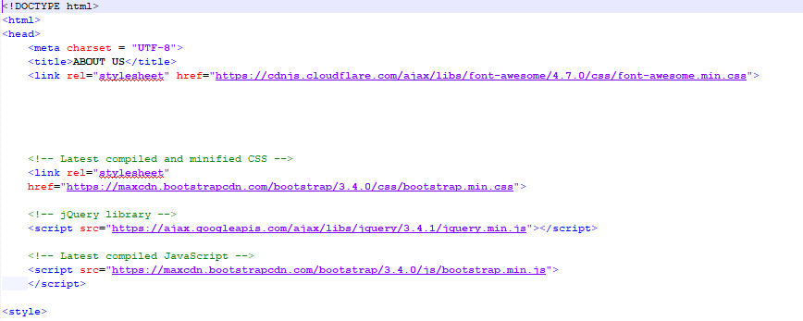Code for this output : “About Us”

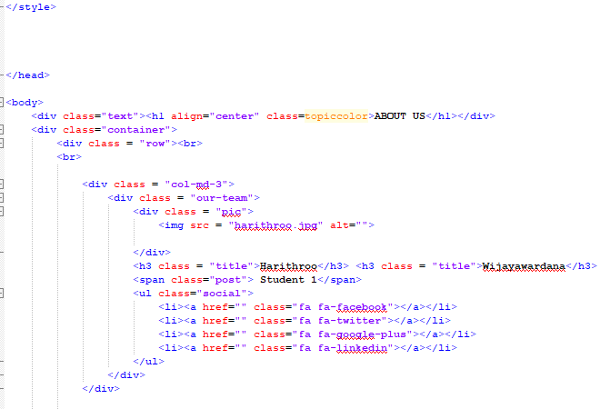

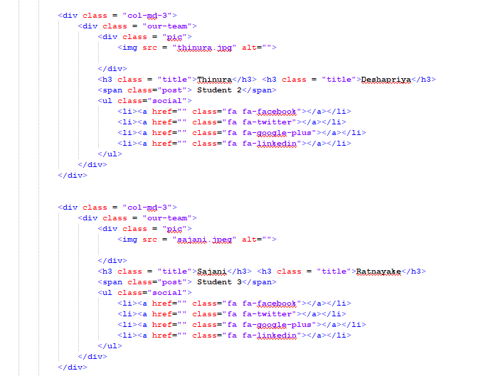

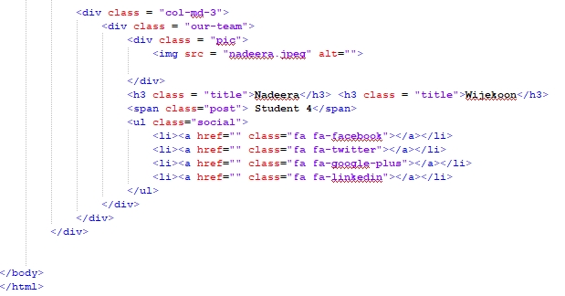

## 2.2 Quiz

* The user can check their knowledge in marvel heroes through the quiz. They can start the quiz by clicking “Quiz” in the navigation bar.
* Suddenly it appears on the website.
* For three specific categories, it will display a gif.
* At last the user will get to know his/her score, the time he/she took, and the number of correct answers.
* I have given 100 seconds to complete the quiz.
* Radio buttons are used to select the correct answers.

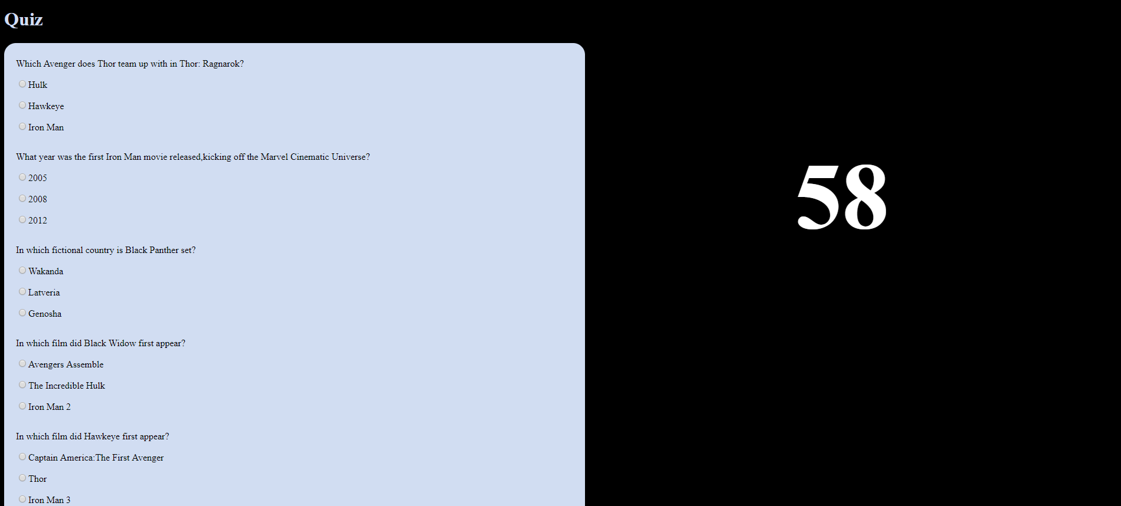

* When user clicks the “Submit” button he/she will get 2 marks for each correct answer and -1 for each wrong answer.
* Also after clicking “Submit” button this quiz will show the user number of correct answers and a comment about the score.
* Also if the user gets all correct, he/she will get,

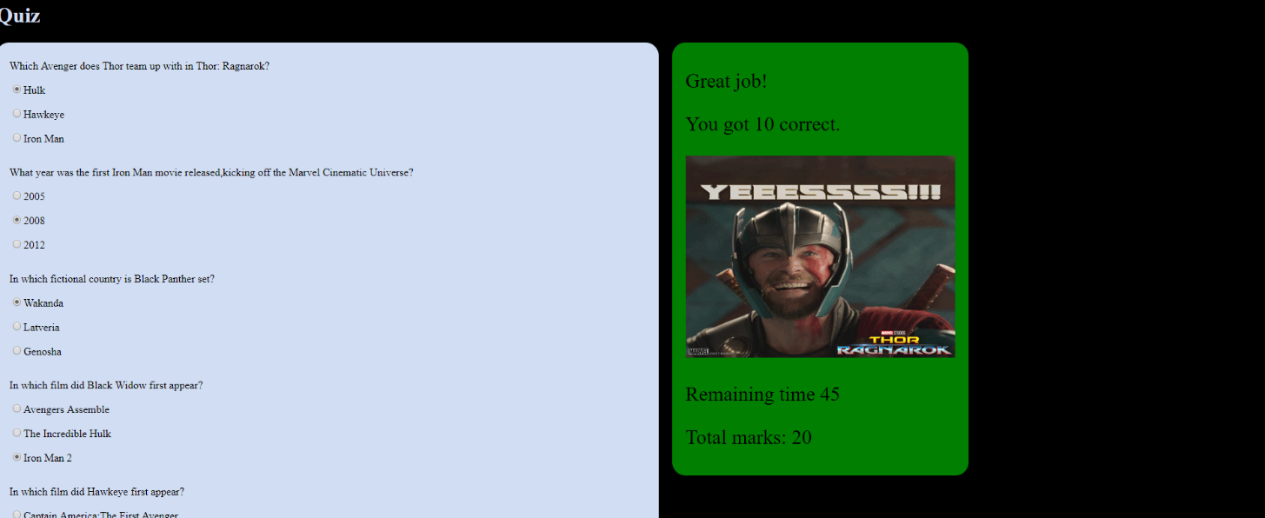

* Background colour changes according to the score, it’s green colour for the total score.
* If the user gets all wrong, he/she will get,
* Background colour changes to red

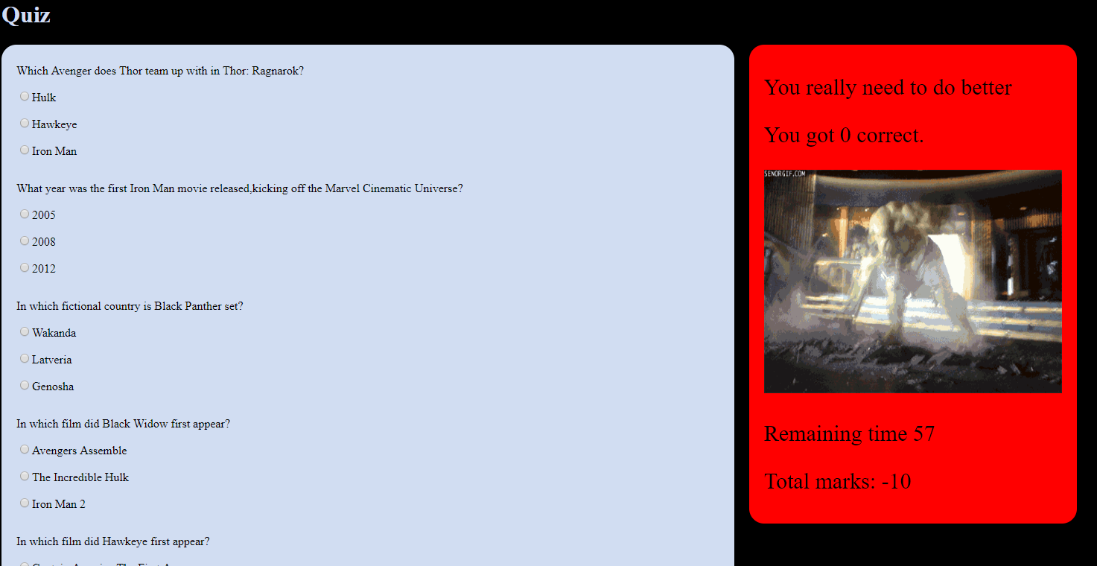

* If the user gets fair score, he/she will get,
* Background colour changes to yellow colour if the user score a fair score.

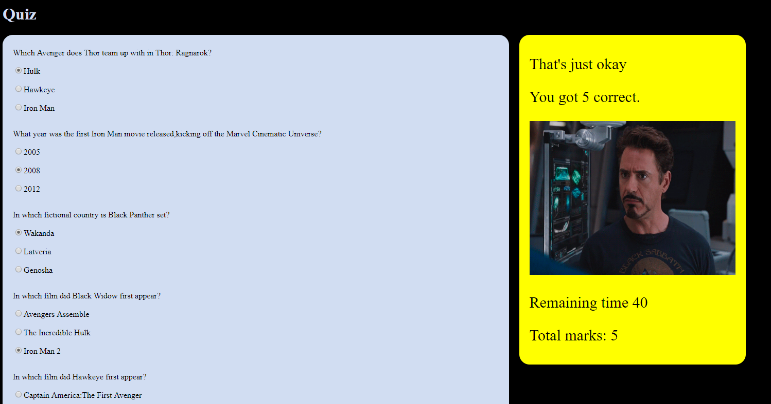

Code for the Quiz:

HTML

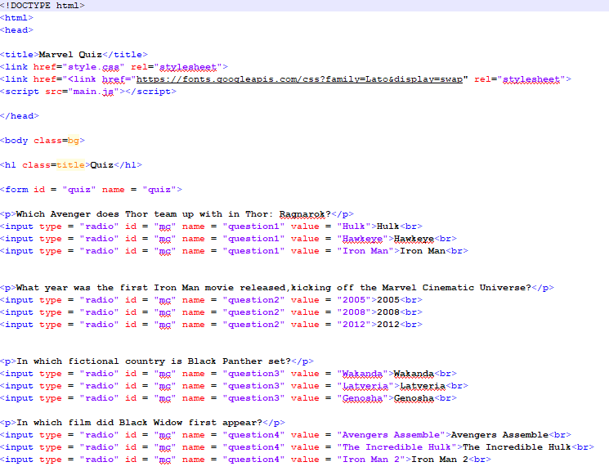

## 

## 

Java Script code:

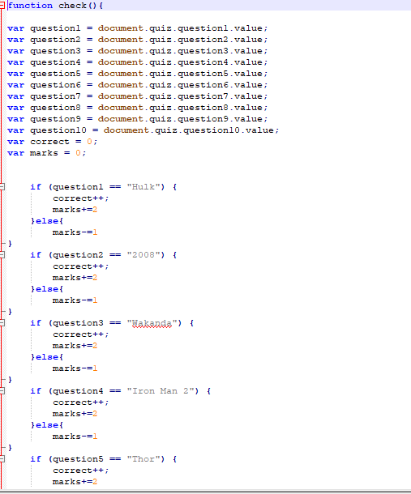

## 

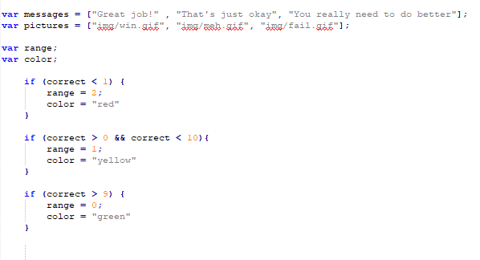

## 

## 2.3 CV

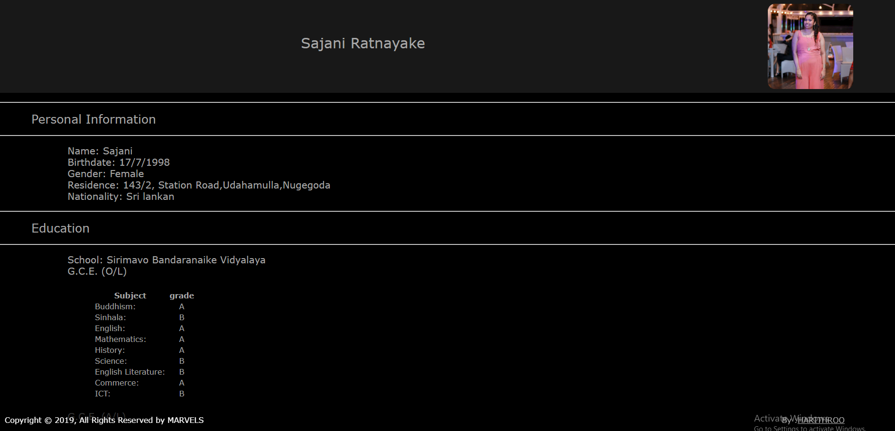

* I have use <hr> tag to represent a horizontal rule.
* I have use tables as well.

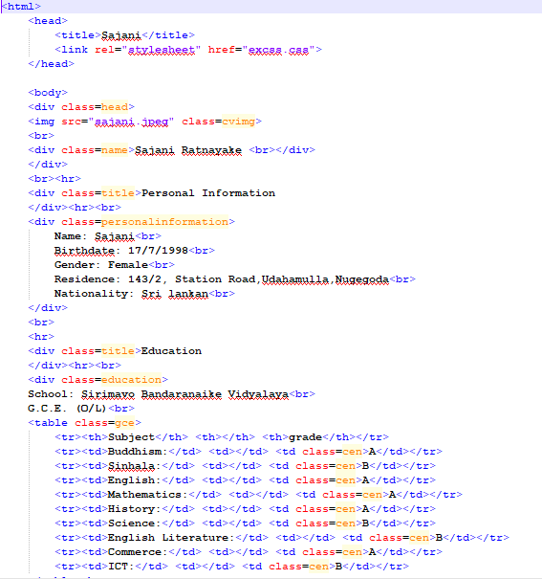

## 

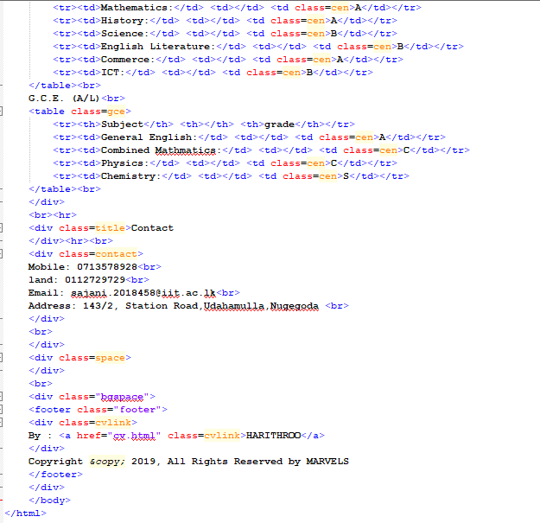

## 2.4 Part 2

* In part B my website, I have position fixed the navigation bar
* My web page is user friendly.
* Each page about marvel heroes linked to the navigation bar under heroes.

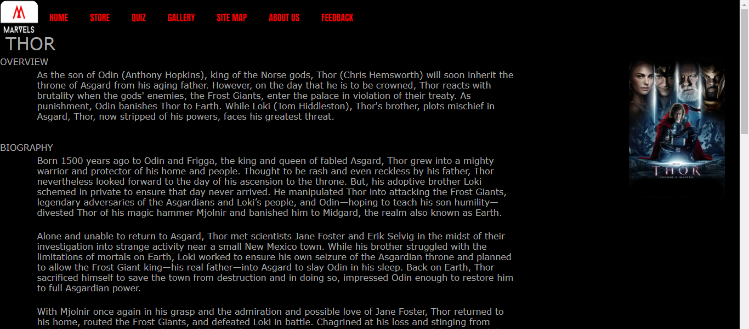

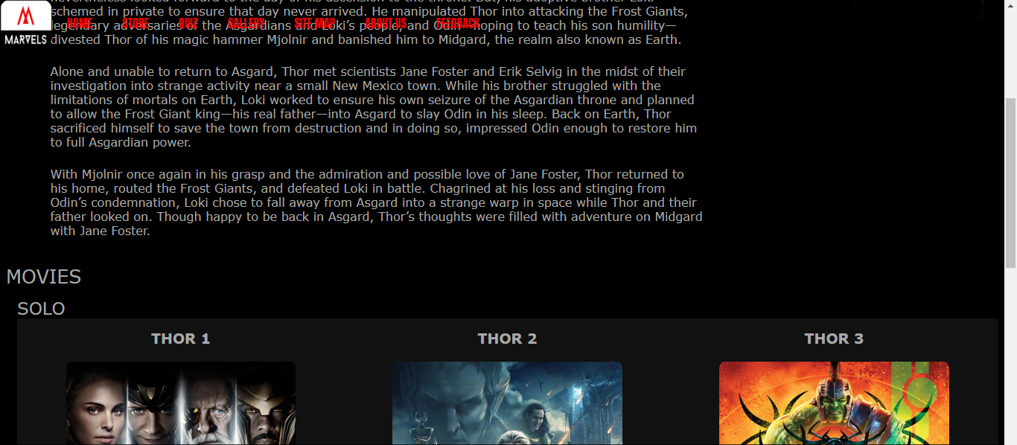

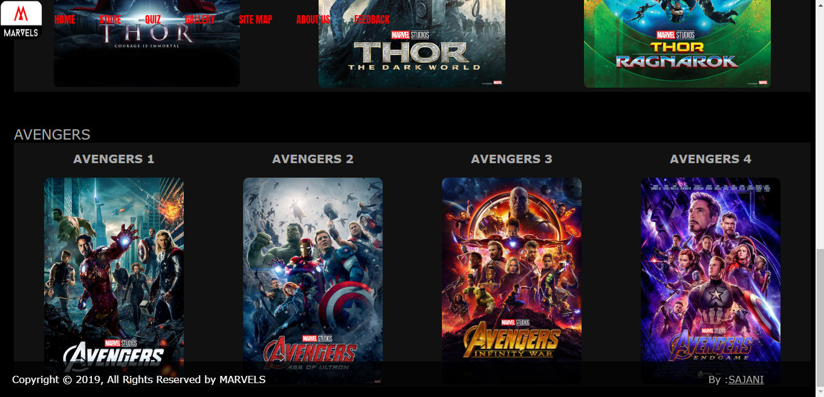

* I have chose “Thor” as the hero, from my page